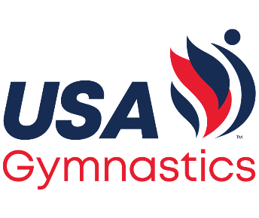
MO USAG Developmental State Meet 2025
Level 2, 3, 4, 5, & Xcel Bronze
March 14-16, 2025
Where: Principia School – 13201 Clayton Road – Des Peres, MO 63131
Meet Directors: Tom and Megan Stevens – Team Central Gymnastics
Equipment: AAI – provided by Midwest Gym Supply
Entry Fee: $85 per Gymnast $50 per Team Entry
Checks made out to: Team Central Gymnastics Please mail entry with payment to: Team Central Gymnastics - 2675 Metro Blvd Maryland Heights, MO 63043
Entry Deadline: It is mandatory to use the USAG Meet Reservation System to register for all State Meets. Rosters must be submitted by February 1st, 2025. (per MO USAG rules)
Payment Deadline: Entries must be postmarked by February 14th, 2025 (per MO USAG rules)
After 2/14/25 a $25 late fee per athlete will be added
Refunds: If a gymnast fails to qualify, your entry will be refunded at the State Meet - ONLY IF – you send an email by midnight March 10, 2025 to: coaches@teamcentral.org. Requests for refunds after midnight March 10, 2025 will not be accepted.
Injury Refunds: Refunds for injuries will be allowed until February 14th, 2025. No refunds will be given except for non-qualification after this date.
Age Divisions: Level 2-5 / Bronze MO Rules and Policies
Awards will be State Medals and awarded up to 50% per MO Rules Team Awards will be up to 50% with a maximum of 10 Team Awards
Qualifying Score: 32.00 - All Around per MO USAG rules and policies LAST DAY TO QUALIFY IS MARCH 9TH, 2025
Gate Fee: Adult - $20/day Child (5-12) - $10/day Senior - $15/day
Under 5 - Free CASH ONLY

Parking: Free

